
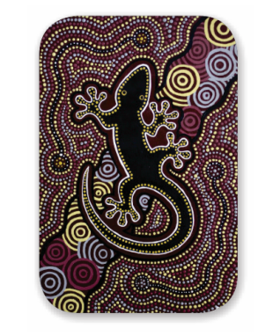
Australian Indigenous HealthInfoNet
The Australian Indigenous HealthInfoNet is a national Internet resource that aims to inform practice and policy in Indigenous health by making the evidence base readily accessible. The HealthInfoNet is helping to ‘close the gap’ in health between Indigenous and other Australians by providing resources such as:
Workshop information
- one and a half to two hours in duration in which time we will run through the website and emphasise those areas and features most applicable to a particular audience
- no more than 20 participants per workshop, and ideally no less than 10 (we have two facilitators and 10 iPads with wifi connectivity)
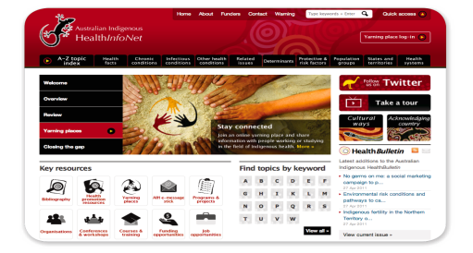
Links
http://www.healthinfonet.ecu.edu.au
http://www.healthinfonet.ecu.edu.au/healthinfonet-workshops
South West dates, locations and times
Please email the date and time of the workshop you wish to attend from the schedule below to
Michelle Catto: m.catto@ecu.edu.au
February 2013
Mon 11th  Bunbury  10-12noon  Bunbury Community Health (Marine Cove room)  Hudson Road  (Minninup Forum end) | Tues 12th  Bunbury  9-11am  SWAMS  Teede St  Bunbury | Wed 13th  Bunbury  9-11am  SWAMS  South West Health Campus  Cnr Robertson Drive and Bussell Highway
2-4pm  Bunbury  Community Health (Marine Cove room)  Hudson Road  (Minninup Forum end) | 2-4pm  Bunbury Community Health (Marine Cove room)  Hudson Road  (Minninup Forum end) | 1-3pm  SWAMS  South West Health Campus  Cnr Robertson Drive and Bussell Highway

