Engaging Young People in the Great Southern Region of Western Australia
Chantelle Stevenson & Cathy Watson
Great Southern Aboriginal Health Service (GSAHS)
Two Projects were developed and delivered
- Dance 4 your life
- Sexual Health Screening Incentive Program
DANCE 4 YOUR LIFE

GSAHS contracted Indigenous Hip Hop Project
(IHHP) to deliver Hip Hop workshops to young people in the Great Southern.
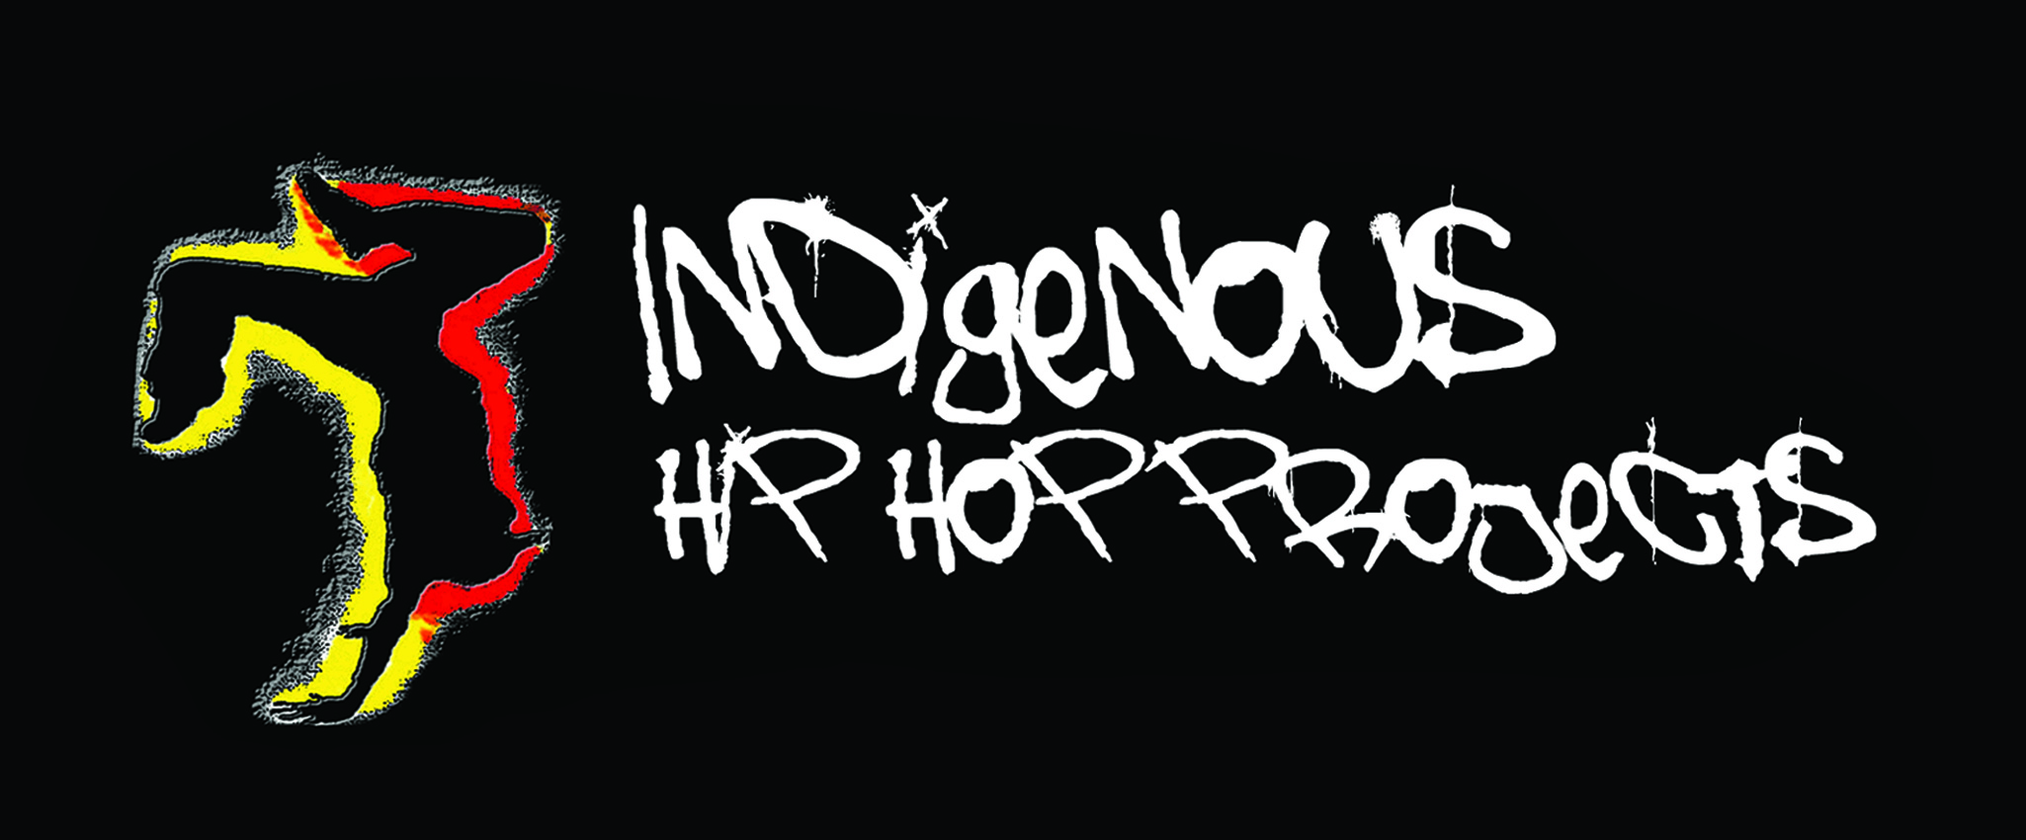

Background
- School-based project targeting young Aboriginal students and ‘at-risk’ young people aged 10-18 years.
- Worked with local schools and youth services.

Project aims and objectives
- Educate the target group to make informed decisions about sexual health
- Increase awareness of sexual health and youth services among the target group.
- Increased awareness among the target group about the importance of positive relationships.

Indigenous Hip Hop Projects
- IHHP is a national multi-cultural arts company that works predominantly with Indigenous communities across Australia.
- Works on the principal of using an ‘arts for change’ approach, focusing on young people’s strengths and developing their skills and attitudes.
- Sponsored by Youth Beyondblue

What did the project involve?
- Hip Hop Workshops (45-60 minutes)
- Connect, show, explain, do, reflect, celebrate.
- Confidence circle
- Battles
- Discussion
- All students received a back pack containing water bottle, hacky sack, pen and information about local services.
- Deadly Stylz Concert
- Artists delivered a performance.
- Students formed groups so they could battle.
- Showcased what they learnt at workshops.
- Students who demonstrated confidence and teamwork given prizes.
- Ended in a open disco
- Signed banner

How was the project delivered?
- 25-29th June 2012
- 40 workshops delivered
- 10 schools participated
- 2 workshops at central PCYC
- 634 students in total attended workshops & concert.
- 116/634 students Aboriginal (18%)
- Approx 80 students at concert – 50 Aboriginal (63%)
Evaluation
- Difficult to do evaluation due to time constraints.
- 5% of students completed survey.
- 97% indicated that they enjoyed the workshop
- 97% indicated that they were more aware of what makes a relationship positive.
- 94% indicated that they were more aware that their choices today can affect their future.
- 97% indicated that they know where to access help for relationships and sexual health.

What worked?
- Dance/Hip Hop proved to be an excellent medium for engaging youth.
- Reached large amount of students – raising profile of GSAHS and other services in the region
- Promoted youth services
- Promoting reconciliation and cross cultural awareness

What could have been improved?
- Level of participation depended greatly on the school.
- Staffing
- Limited evaluation
- Lots of Work!!!

Get Yourself Checked!

Sexual Health Screening Incentive Program

Background & Rationale behind the project
- Screening rates are low among clients accessing GSAHS.
- Snapshot of Chlamydia rates among target group.
- To make screening simple and accessible

Aims of Project
- Decrease shame around testing – among AHW’s & community.
- Increase awareness about the simple nature of testing.
- Increase awareness of sexual health.
- Increase capacity of health workers to address sexual health issues with clients.
- Promote testing among GPs in smaller towns

Resources- Creating a Poster
Sorry because its too big to post here but the poster has lots of colour, plain language and with a young person focus.
Mail out letter
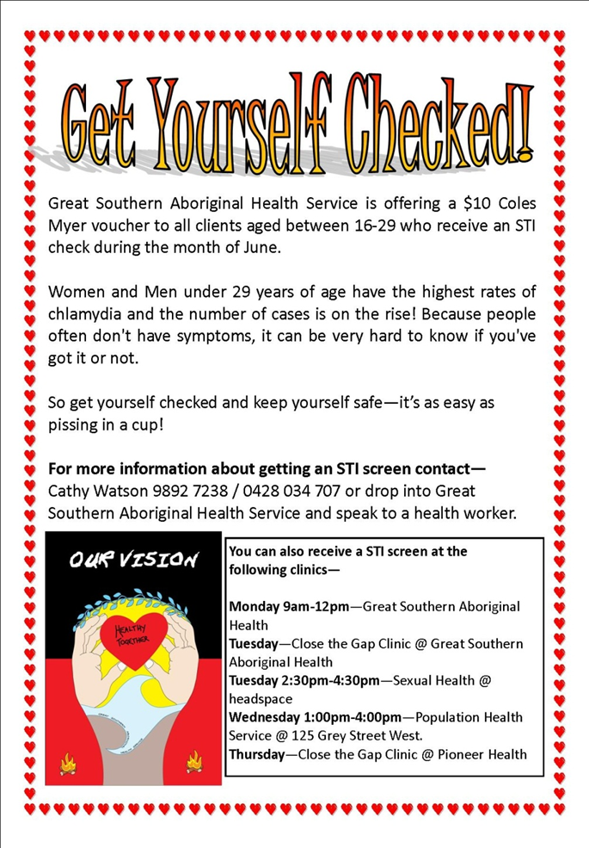

Networking
- Community 1-the doctors who provide a CTG clinic based at GSAHS
- Community 2– medical service liaison with the Practice nurse
- Community 3. Thru Nursing Post
- Community 4- Practice nurse
- Youth services- headspace, Young House and Palmerston

Procedure
- Self assessment form
- AHW to provide specimen collection material- Yellow top jar or PCR Swab
- Explain to client how to obtain specimen either first void urine or SOLVS
- The GP or Nurse provided the pathology forms.
- Once we had a specimen then we would give clients the voucher.
- We sent the specimen off to Pathwest.

Mail out to Regional Population Centres
- We mailed out to ~150 clients over 6 towns
- Only one response.
- I visited Community 5 on a regular basis to offer clinic as they didn’t have the same set up as the regional centre
- Presentation at YAP clinic (Palmerston)
- One client from Community 4 was seen in Regional Centre
Results
Mail out |  | Screened | M/F | Mail out response
Community 1 | 200 (10RTS) | 16 | 1/14
Community 2 | 35 | 0
Community 3 | 100 (5RTS) | 9 | 1/8
Community 4 | 11 | 1 | 0/1 | 1
Community 5 | 30 | 0
Community 6 | 20 | 1 | 0/1
TOTAL | 396 | 26 | 2/24 | 1

Evaluation
- Improved screening
- Detection rate (increased)
- Test of cure
- Continue to give out vouchers
- Future
- Challenge “How to improve male test rates?”

Further information is available by contacting Chantelle or Cathy direct on (08) 9892 7222

