Drink Driving and Licensing Toolbox for Indigenous Communities in WA

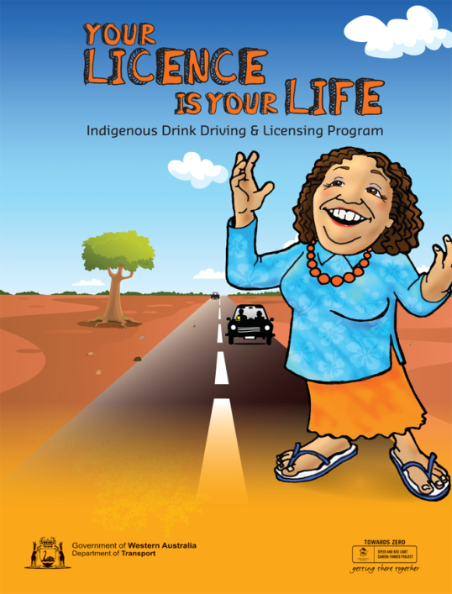
The Office of Road Safety in Western Australia has created a simple and easy to understand educational resource to make the process of getting a driver’s licence easier, and to spread the word about drink driving.

“Indigenous people are over represented in road crashes and are 25 times more likely to be imprisoned for driving under the influence than non-Indigenous people,” ORS Senior Policy Officer, Julie Dalla-Costa said.

“They are also more likely to drive unlicensed or to never have held a driver’s licence.”

“We want to start to change the conversation about drink driving and driving without a licence and to create an understanding in the community that it’s worth the effort to get their licence and make better choices about drinking and driving.”

“The resource kit has been designed for people working with Indigenous communities in regional areas of WA and has been developed in consultation with stakeholders and Indigenous people across the state.”

The consultation found that the resources should be visual, aural and interactive, and focus on the emotional and social consequences of unlicensed or drink driving, such as the impact it would have on family and employment.

The kit as a result contains a range of interactive resources specifically developed for Indigenous Western Australians including a board game, discussion cards, a streetscape mat with model cars, and a Q&A CD containing practice Learner’s Permit theory tests with the option for people with low literacy levels to listen along and a questionnaire to help people prepare for the application process.

Other educational materials in the kit include a DVD starring Mary G that explores the issues surrounding unlicensed and drink driving, a poster that encourages alternatives to drinking, several booklets and a DVD of Road Safety Council TV campaigns created by Goolarri Media.

The kit is funded by the Road Safety Council and is available by contacting Julie Dalla-Costa at the Office of Road Safety at Julie.Dalla-Costa@mainroads.wa.gov.au or on 9323 4690.

