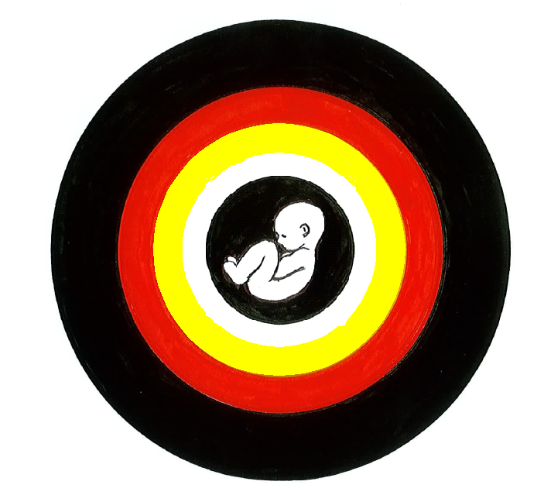Marulu

OVERCOMING FETAL ALCOHOL SPECTRUM DISORDERS (FASD) AND EARLY LIFE TRAUMA (ELT) IN THE FITZROY VALLEY: A COMMUNITY INITIATIVE

Update Report 2/2010 July 2010

Community says FASD is health priority for Fitzroy
The Fitzroy Futures Forum discussed the draft Local Implementation Plan on 29th June. One of the plan’s health priorities is: Funding a Coordinator for the Marulu (FASD/ELT) Strategy, and Stage 2 of the Lililwan Project (FASD Prevalence Study).
A long-term paid coordinator for the Marulu Strategy would be a great outcome of the work over the past two years by the Marulu Strategy Leadership team and the volunteer coordinator Meredith Kefford.
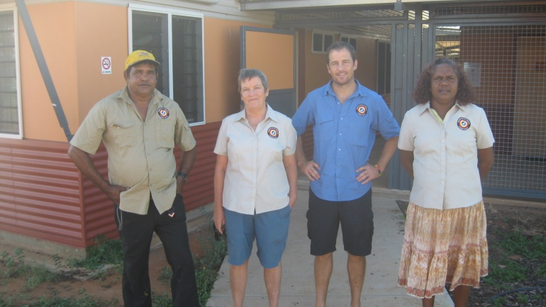
The Lililwan Stage 1 team L-R: Harry Yungabun, Meredith Kefford, James Fitzpatrick, Rhonda Shandley.
Lililwan Stage 1 nearly finished! Thanks to everyone involved!
The Lililwan Project is part of the overall Marulu Strategy. The February 2010 Marulu update explained the two stages of the Lililwan Project. Stage 1 includes:
- Collecting information about pregnancy, birth and early childhood from parents/carers of kids born in 2002 and 2003 using a diagnostic checklist and reviewing health records, and
- Community education around healthy pregnancy and childhood, and FASD.
This work started in April. We have now contacted the parents/carers of 134 of a total of 138 kids in all the communities across the Fitzroy Valley, with 127 agreeing to participate (95%). People were generous with their time for a detailed interview, and honest and brave in their responses to personal and difficult questions. They knew that the project is about helping kids now and into the future, not about the past.
The Stage 1 team has two community navigators, Rhonda Shandley and Harry Yungabun, working with Meredith Kefford and Dr James Fitzpatrick, a kid doctor and Project leader. Rhonda and Harry, with Emily Carter from the Nindilingarri Alcohol and Drug Program and Maureen Carter advised on working in and with local communities, and making the interview questions relevant and acceptable to local people. The team visited most communities, often having a BBQ and camping for one or two nights while getting to know the community and locating the people we wanted to interview. All the communities and organisations were incredibly welcoming, and there is no way we could have got this far without all the help and support we received. In particular we want to thank:
- Parents and carers across the Valley, for their generosity and honesty in the interviews
- Every community, including schools, clinics, stores, and offices for publicising, helping with places to stay, locating people, making links, and telling their stories.
- The many Fitzroy Valley organisations that helped and supported the work
- Our partners The George Institute of Global Health and Sydney University Medical School. Their expertise and resources have has been absolutely crucial, and given with unfailing respect and commitment.
- The anonymous donors who funded Stage 1.
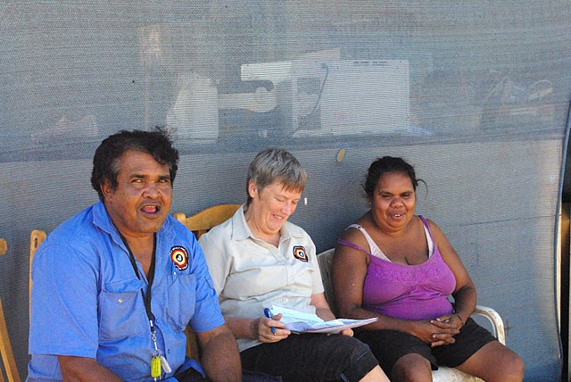

A Lililwan Stage 1 Interview at Wangkatjungka

What’s next in Stage 1?
In the second half of August, the Stage 1 team will revisit communities across the Valley to:
- Run information sessions on healthy pregnancy and early childhood, including FASD
- Collect feedback and discuss Stage 1
- Start planning for Stage 2.
The information from the interviews and medical records will be collated and analysed, and used for the health assessments in Stage 2.
The information will be summarised in a Stage 1 Report, which will be sent to all the partipants who requested feedback, and available to other people on request.

Lililwan Stage 2
The next stage is a full health assessment of the kids born in 2002 and 2003 by a team including kid doctor, nurse, allied health workers and psychologist.
Children who are found to have health or developmental problems including FASD will be given treatment and ongoing support where possible.
It’s great news that the Australian Government has promised funding for Stage 2. The work will start late 2010, and be finished during 2011.
However, we need more resources across the Fitzroy Valley (and in other parts of Australia) to help people with FASD reach their full potential.
The information from Lililwan Stage 2 will be used to convince state and federal governments that more help is needed to prevent FASD in the future, and help people already affected. Nindilingarri and the Marulu Leadership team will fight to make sure that the Lililwan Project makes a real difference across the Fitzroy Valley.
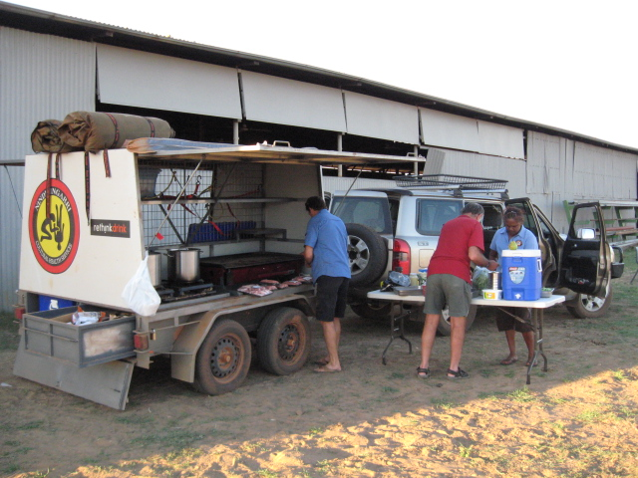
Preparing the Nindilingarri Trailer for a Community BBQ at Noonkanbah

More information

Marulu Leadership Team Chair

Maureen Carter
(08) 9193 0093

Marulu Strategy Coordinator
Meredith Kefford
0427 958 718

hp.worker5@nindilingarri.org.au

maureen.carter@nindilingarri.org.au

Dr James Fitzpatrick
0403 198 769
gettingvision@gmail.com

