Working Together with Tiwi:

Cross Cultural Awareness Training

(Teddy Portaminni)
- Date:
Dry Season
- Location:
Bathurst Island Northern Territory
- Category:
Indigenous

Overview
The Tiwi people hold fond memories and excellent skills in relation to ‘going out bush’. The training is designed so participants can share in this experience firsthand with Tiwi families.

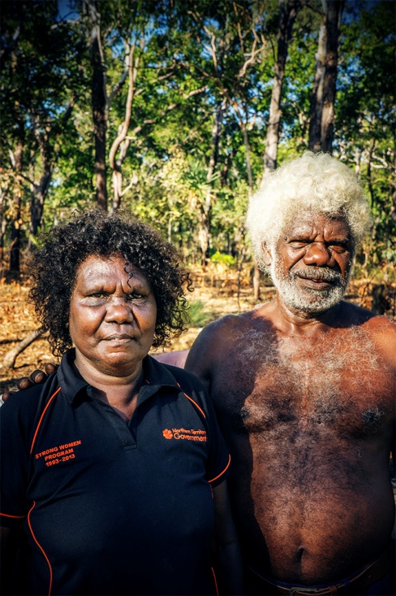
The Tiwi Cultural Awareness Training supports the maintenance and continued development of Indigenous culture. An emphasis is placed on healing and building community sustainability and the training is facilitated by members of the local Indigenous community.

Purpose: Increase understanding about cultural identify and connect with the nourishment and resources of cultural knowledge.

Topics covered by the training include:
• Tiwi culture
• Cross-cultural communication
• The impact of attitudes
• Beliefs on styles of work and communication
• Key issues involved when collaborating with Aboriginal people

This training is experiential in nature, so participants can expect to take part in Tiwi lead activities including fishing, hunting, mangrove walks and finding fresh water creeks.

Night time around the fire is a particularly special time for story-telling, songs and cultural explanations. Teddy is available and responsive to questions about the Tiwi way. The fire place is a central place for gathering times and reflection on the day’s experiences.

A two hour PowerPoint presentation can also be included in the training or be provided as a standalone workshop.
Recommendation from a recent participant as illustrated by the following reflections from Doctor Merinda Crowe:
“Everyone who works with Aboriginal people should have the opportunity to experience this camp because it gave me a real appreciation of the richness and uniqueness of Aboriginal culture. The cultural immersion camp was a fantastic experience. Going out to country and delving into the customs of Tiwi culture was a truly unique experience. I think it is so important to understand about life from an Aboriginal perspective in order to understand how to effectively communicate with Indigenous clients. It was delightful to be included in Teddy’s culture and a part of his family for a few days. It was very humbling to experience their ancient culture for a few days. I felt encouraged after leaving the camp because of the way Teddy’s family was passionate about being healthy and ‘growing up their children the right way’. I would highly recommend this camp. Everyone who works with Aboriginal people should have the opportunity to experience this camp because it gave me a real appreciation of the richness and abundance of Aboriginal culture.”

Teddy Portaminni is a Tiwi elder and Traditional Owner from the Tiwi Islands. He has a high level of knowledge and experience in education and issues impacting Aboriginal families and communities.

Contacts
Teddy Portaminni
Bathurst Island
Ph: 0438350184
Email: teddyportaminni@hotmail.com

