

Western Australian Aboriginal Education and Training Council (WAAETC)

INVITES YOU TO A FREE

Parental and Community Engagement (PaCE) Workshop
PaCE funded by DEEWR

Come along, learn and talk about
how we can support
- our children
- our families and
- our community
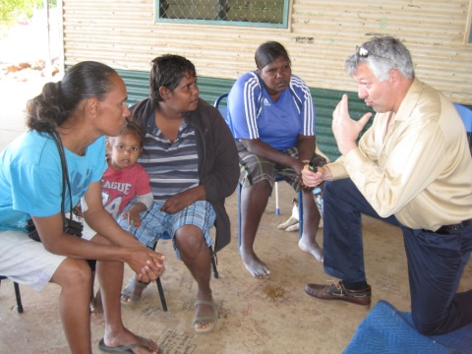

Facilitated by Gerry Cleveland in
partnership with the WAAETC

WHEN: Monday 30 July 2012
Tuesday 31 July 2012

WHERE: Technology Park Function Centre
2 Brodie Hall Drive, Bentley
Free parking available
Catering supplied

TIME: 9:00 am – 3:00 pm

Put your name down for the workshop to help us with catering by calling
MICHELLE on (08) 94411936, Email Michelle.esterhuizen@des.wa.gov.au

or LESLEY (08) 9441.1908, 0448 215 202, Email: Lesley.Radloff@des.wa.gov.au

