

Western Australian Aboriginal Education and Training Council (WAAETC)

Parental and Community Engagement (PaCE) FREE Workshop
PaCE funded by DEEWR

Want to learn more
about how to teach our
Nyoongar history?

Come along to the workshop
Facilitated by Sandra Harben in partnership with the WAAETC
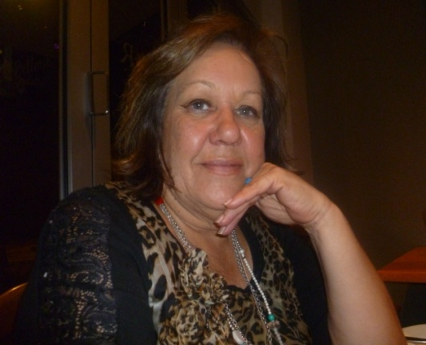
WHEN: Thursday 31 May 2012
&
Friday 1 June 2012
WHERE: Merredin Regional Community & Leisure Centre
Bates Street
Merredin

TIME: 9.30 am – 3.00 pm

PLEASE REGISTER: Call Michelle at the WAAETC on (08) 9441 1936

EMAIL: michelle.esterhuizen@des.wa.gov.au

You can also register by calling Carol Garlett 041 7911 877

