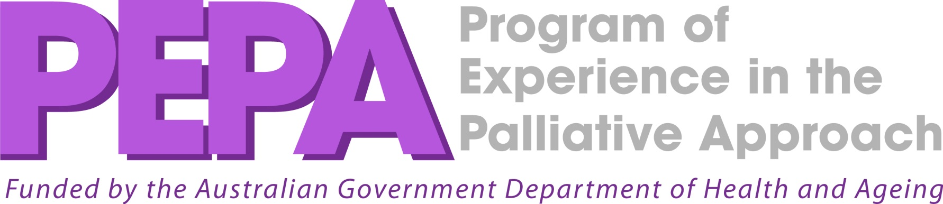

Aboriginal Cultural Safety in Palliative Care

This two day program is targeted for health professionals to develop their skills in caring for Aboriginal people and their families facing a life limiting illness and will explore the topic of cultural safety in palliative care. Topics include:
- An introduction to cultural safety.
- An introduction to the history of Aboriginal people.
- Enhanced awareness of kinship and community systems.
- Active communication with Aboriginal people on palliative care issues.
- Loss and Grief
- End of life issues.

PRESENTERS: Cancer Council Clinical Nurse Educator
Robyn Ellis - Local Palliative Care Coordinator
Joyleen Koolmatrie is a descendant of the Ngarrindjeri and Kayteye people in South Australia. She is now based in Perth, and works primarily with Aboriginal people delivering psychological services in the area of loss, grief and trauma.

DATE: 6th & 7th June 2012

TIME: 9:00am – 4:00 pm

VENUE: Nazareth House
Crowtherton St, Geraldton

COST: Free (Funded by PEPA Program)

CATERING: Morning tea and lunch will be provided

RSVP: Registrations are essential as places are
limited. Contact the Cancer Council, Palliative and Supportive Care Education Team on 9382 9300 or
Pdadministration@cancerwa.asn.au


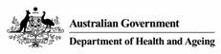
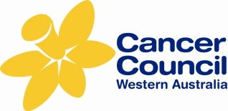
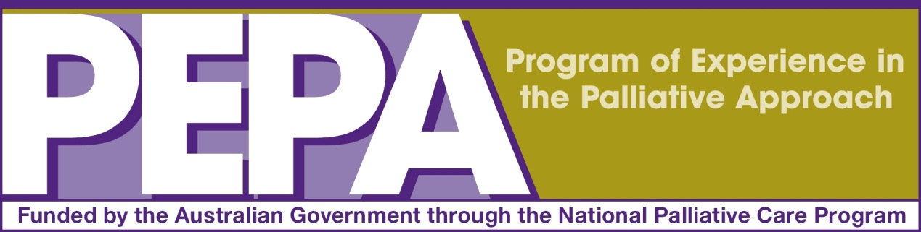

Palliative and Supportive Care Education Team

COURSE APPLICATION FORM

COURSE TITLE |  | DATE OF COURSE
PARTICIPANT DETAILS:
Full Name: Date of Birth:
Mailing Address:
Email Address:
Telephone No: | Fax No: |  | Mobile:
Position: Volunteer
Workplace: Private / Public (please circle)
Do you identify yourself as an Aboriginal or Torres Strait Islander
What language other than English do you speak at home?

Please return to: Palliative and Supportive Care Education
15 Bedbrook Place Shenton Park WA 6008
Phone: 9382 9300 Fax: 9381 8103
Email: Pdadministration@cancerwa.asn.au
All sections of this form are required to be completed. A notification of registration will be sent to the email address supplied below.

ABN 15 190 821 561

